Guidelines for Worship

St. Dysmas Lutheran Church
South Dakota State Penitentiary (SDSP)
1600 North Drive, Sioux Falls, SD
St. Dysmas office: 605-338-1735

PLEASE BE IN THE PRISON ENTRANCE - LOBBY

BY 1:15PM.

YOU WILL NEED YOUR DRIVERS LICENSE OR

GOVERNMENT ISSUED PICTURE ID.
The name on your DOC Access form must appear exactly as it does on your driver’s license

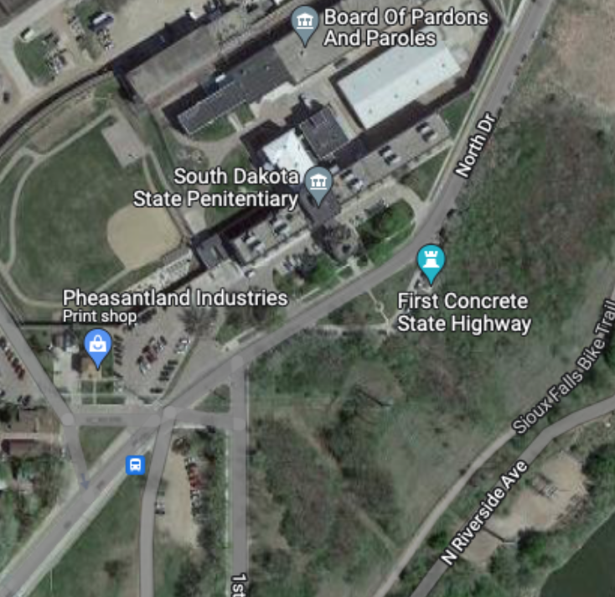
Parking Lot
Parking Lot
Prison Entrance - Lobby

- Your visit to a St. Dysmas worship is important to the men. They greatly appreciate your attendance! It is a way for them to maintain contact with the outside world, worship with fellow sisters and brothers in Christ, and to know they have not been forgotten. Your time with the men of St Dysmas directly relates to what our Lord speaks of in Matthew 25 and Hebrews 13; to visit those in prison.

- DRESS CODE for prison visitation is conservative.

  - Clothing NOT ALLOWED: Hats or any headwear (including bandanas), hooded sweatshirts, open-toe shoes, flip flops, shirts/tops of the following nature - tank, spaghetti strap, midriff, tube, shoulder-less, back-less, halter, or low cut. No shorts, stretch or yoga pants, tight jeans, dresses/skirts shorter than knee high. Low-rise pants which allow skin or undergarments to be seen may be deemed inappropriate by staff.

- Pockets must be emptied of all items unless pre-approved (keys, wallets, pens, knives, cell phones, candy/cough drops/gum). Any medications you MUST have with you must be pre-approved.

- Items not allowed to be taken into prison: No gum, food, cameras, purses, coats, pocket-knives, tobacco products, smart watches, fit-bits, cell phones, beepers, or any other type of wireless or electronic devices (even if turned off or set to vibrate). They can be left in your car or stored in a locker in the lobby (cost is 25¢).

- Screening and/or pat-down searches are required for all visitors.

- Please be quiet in the Sally Port. If the officer needs to say something it is difficult to talk over others through the glass.

- Visitors should sit among the men in small groups of two to three people. A handshake is the only allowed physical contact between a visitor and inmate.

- DO NOT ask inmates why they are incarcerated, ask for, or accept, an inmate’s mailing address, offer help or promise favors. DO NOT give out your personal information such as your full name, address or phone numbers to inmates. There are proper channels for inmates and families if they need help.

- A restroom is available at the bottom of the stairs in the prison lobby. A restroom is not available once you are inside the secure area, so please be sure you are set before entering the prison.

- Masks are optional for everyone entering the prison. If you are sick or not feeling well, please do not attend.

- For those with limited mobility, please notify us of your needs. We will try to accommodate your needs to attend worship.

- Questions? Call the St. Dysmas office at (605) 338-1735 or Pastor Jeff Backer’s cell phone at (605) 360-3409.

